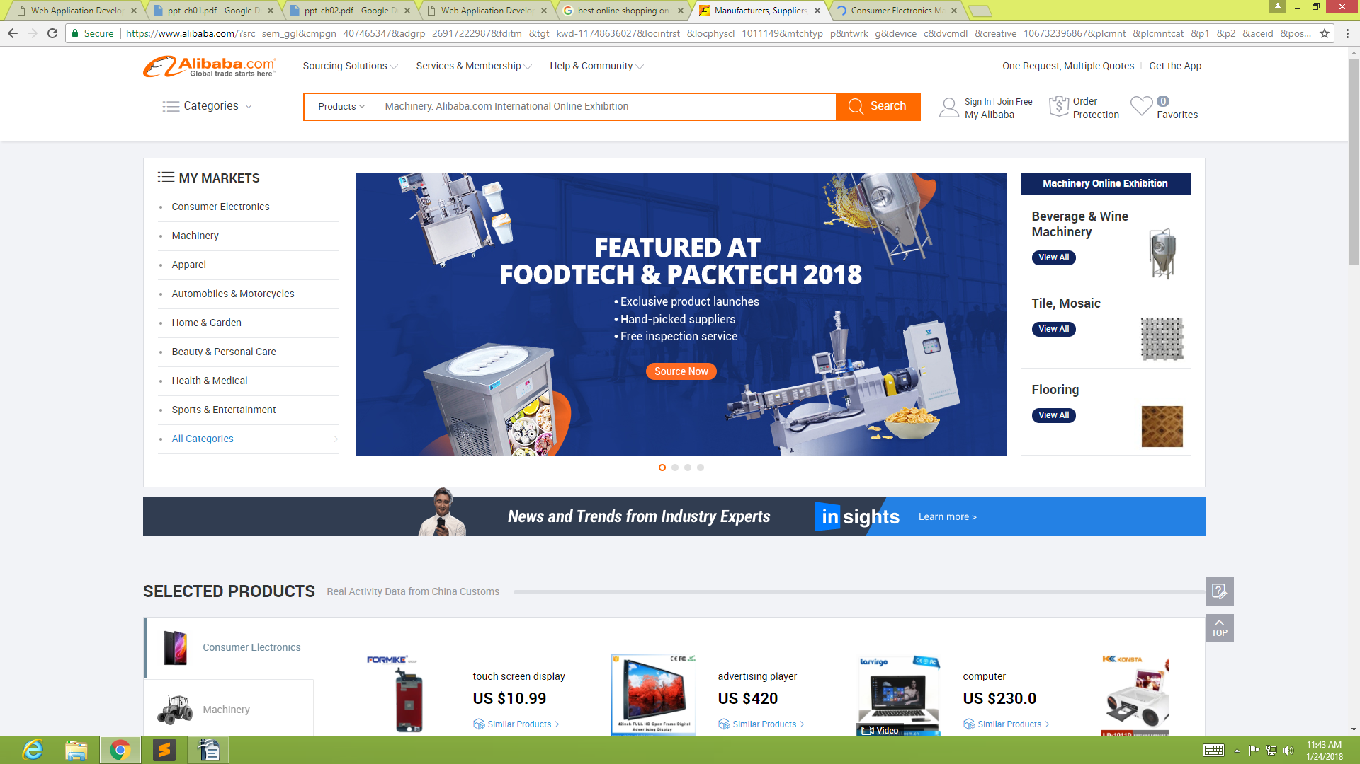
1. GOOD DESIGN

Banner

Menu

Passive
White
Space

Passive
White
Space

Search
Tool

Active White
Space

Consistent logo and
site navigation
Leftover screen space is equally distributed on both side of the browser window

Fixed
Columns
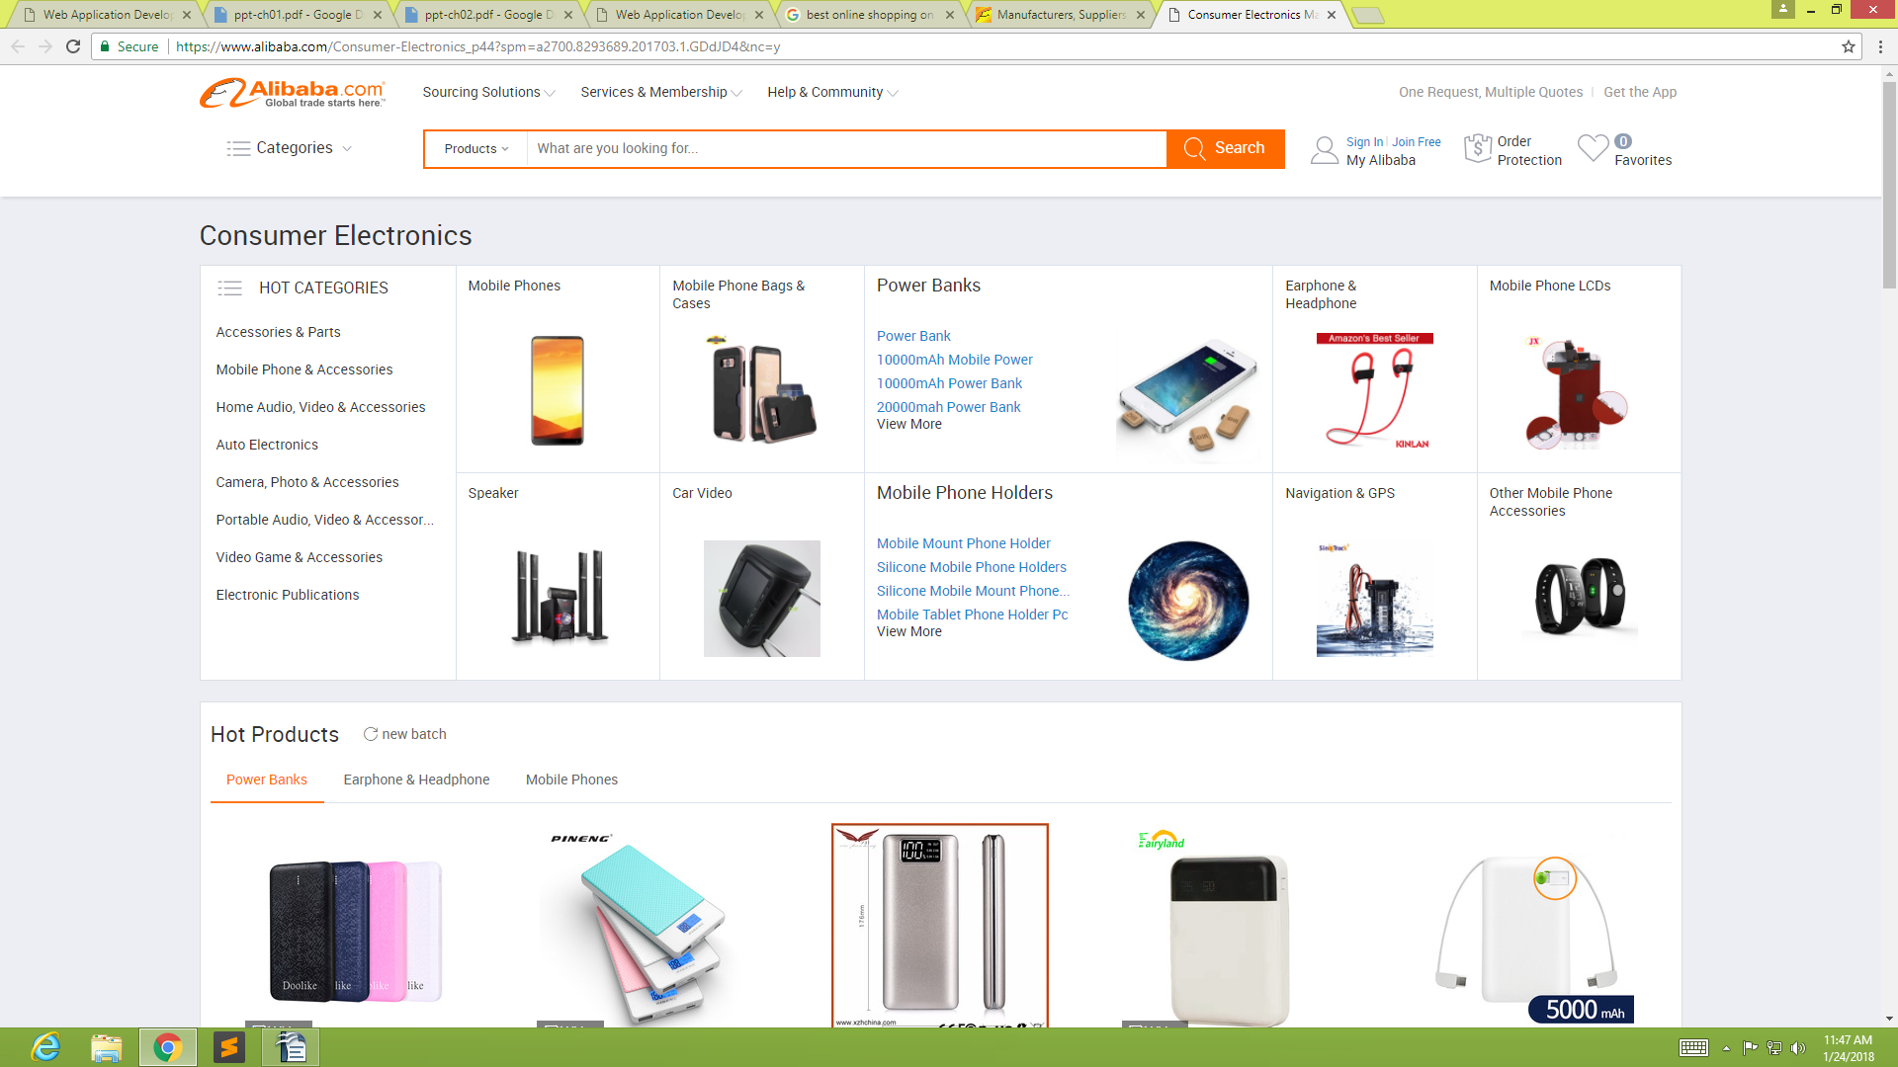
The layouts for the two pages suit their information types and the needs of their users in the way the if you click one of the categories it open a new page then everything that a user needs was in the categories that he click. It has a specific place of items in the categories so it is easy to locate anything that a user needs.

Content
Content Fixed on one display area
Leftover screen space is equally distributed on both side of the browser window

The design of the site is appropriate for the content because at the first place the user can easily view or locate the thing that a user need. Also the content of the site is nice because at first the logo of the site show what can a user get or what a user looking for. Then the site have its own categories what a user want to search for.
No Passive and Active White Space
Search
tool

2.POOR DESIGN
Everything is
compress
Banner
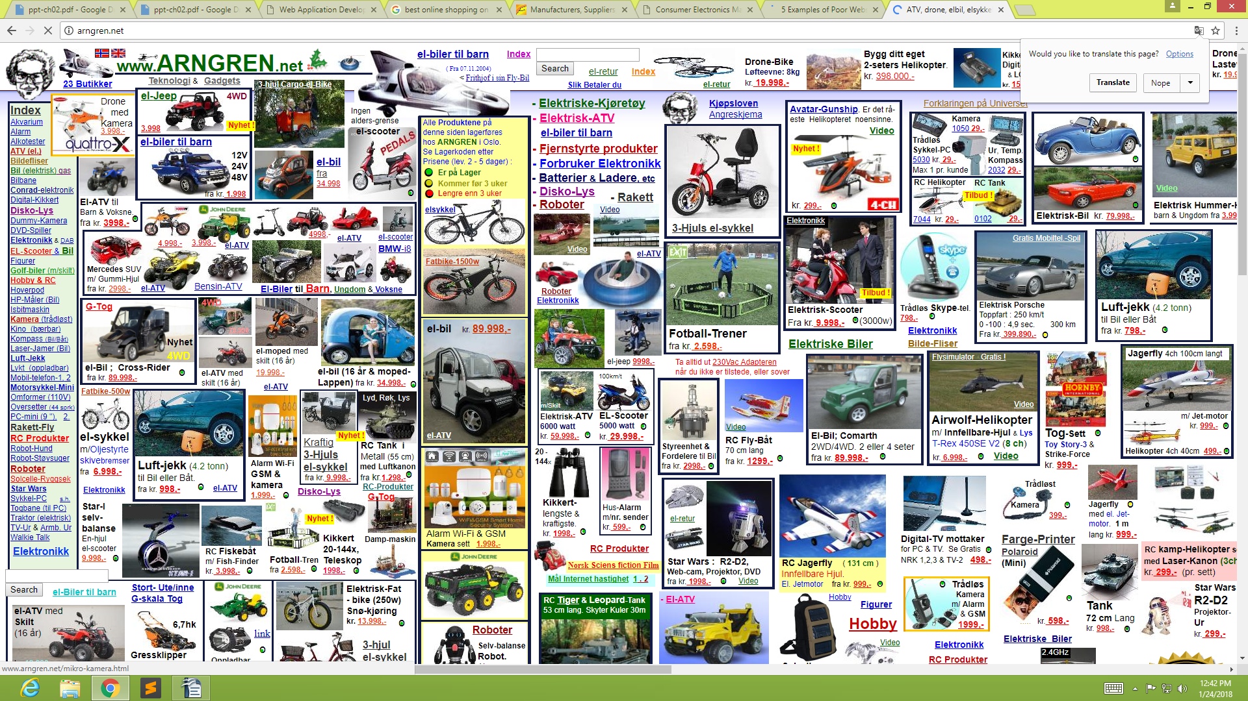
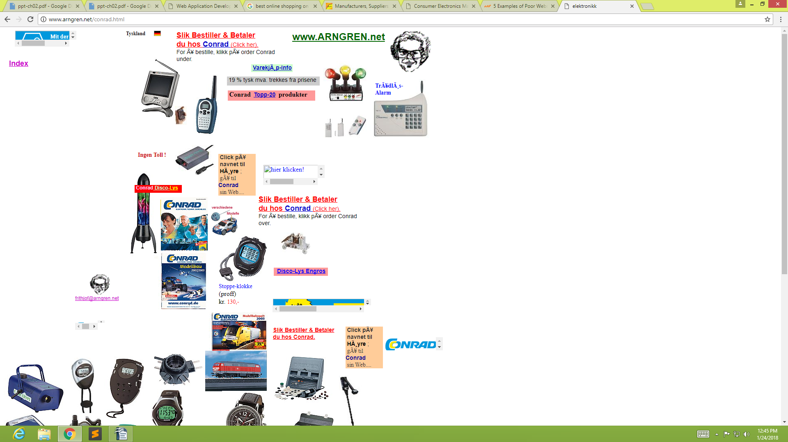
Many Categories but if you click it ,combination of other items

Passive White Space
Leftover screen space is equally distributed on both side of the browser window
Passive White
Space
The layout is not really good at all.
- My recommendations for improving the site design is that is should be not compress it should have spaces like active and passive white spaces because user will not able to locate the item what they needed also in the categories of this site. Also they should not put other item for specific categories.

- Write a short essay critiquing a Web siteâ€™s design. Describe the structural layout of the site and determine whether information is presented clearly and is easily accessible.

First in making a design you should able to think first wheather it can help user or it can do nothing at all and catch the attention of the users. After that you you should able think what are the thing you need to put in your website before you make a categories . Then after that think first what kind of layout you need to do for it.t can attract clients if presented the right way or it can scare them off when it lacks focus or has typos. Paying close attention to what you write and how can make a huge difference. Think of an average reader – use clear and accessible language that everyone can understand. Make sure what you’re offering is obvious and highlight the reason they should buy it from you. Most importantly, don’t exhaust your visitors with long, ‘essay’ style texts. These days what people respond to best are strong images with short, elegant descriptions. An average website consists of a home page, an ‘about’ or bio page, ‘portfolio’ or ‘products and services’ page, and a ‘contact’ page. Make sure you have the appropriate text for all pages.If you’re not sure what your brand is, ask yourself some questions: is your business all about fresh, modern, innovative products? Is it about offering the cheapest prices for services in your field? Maybe it’s all about tradition, privacy and confidentiality? Whatever your line of business is, make sure your logo represents you right. Photos of your products, a portrait photo for the ‘about’ or ‘bio’ section, an introductory photo for your home page, etc. Since we’re living in the age of images, you need to choose your images carefully and make sure they’re high-resolution and the best possible quality. Stock photo websites are a good source of good photos but you should use them as your last, not first, resort. Strong, original photos have an appeal that no stock photo can compete with.

    - Browse the Web for sites that use unique navigation methods. Write a short essay describing why the method is or is not successful, or prepare a short slide presentation that you can present to your class.
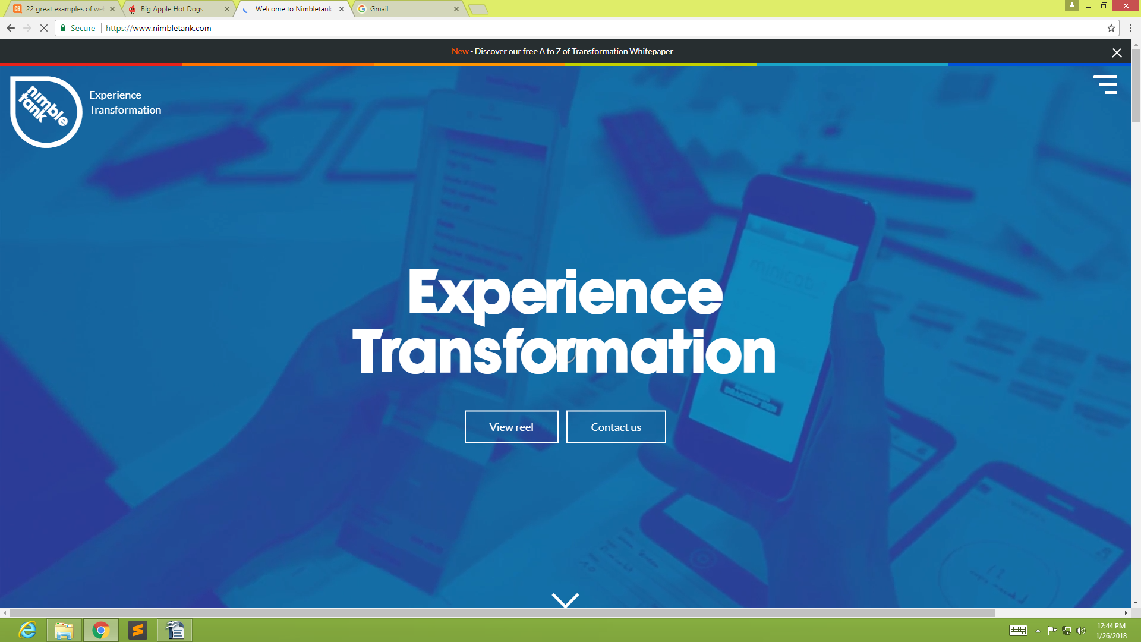

-A good navigation system gets you the information you need quickly and easy. A great navigation makes you smile while you're doing it. That's just what London-based freelance creative developer Daniel Puhe and the team at mobile website agency Nimbletank have come up with.
This agency site offers an interactive and fun experience involving 360-degree movement and old school Tetris game references. Offering a multi-functional journey through what the agency has to offer, the site is aimed at touch devices but also works on desktop, where there's a 'Rotate' button in the corner to mimick the rotation of an iPad. Also everything that you need is was in their like transforming finance, enterprise apps, trasforming health and lastly innovating golf everything on was have their on mission about their blog ,if you view it every details you need is on inside of it.

5.Find a Web site that you think needs improvements in itsÂ design.
  - Print two pages from the site.
  - Make copies of the originals, and set the originals aside.
  - Using scissors, cut out the main elements of each page. Rearrange the elements and paste them in a design you believe improves the site.
  - Compare and contrast the original with your improved design.
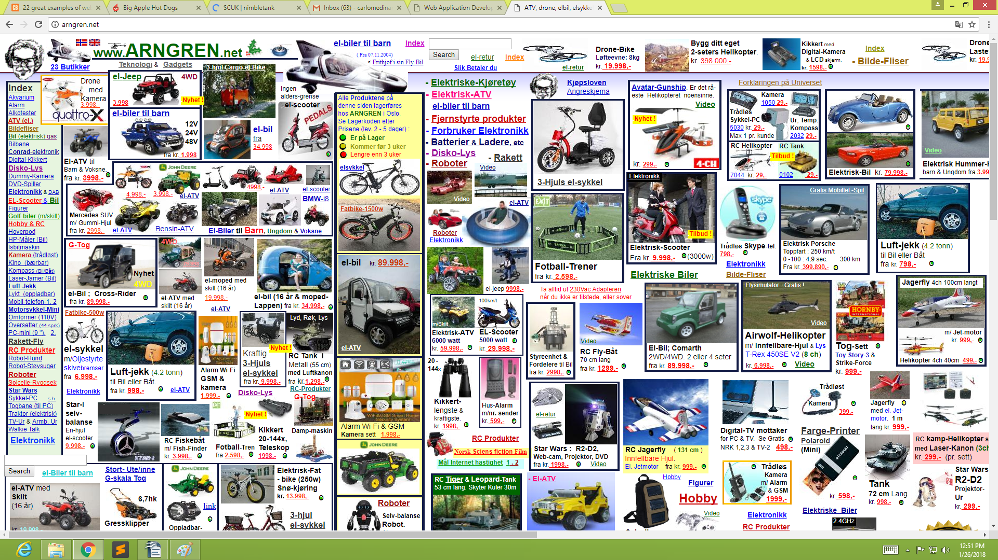

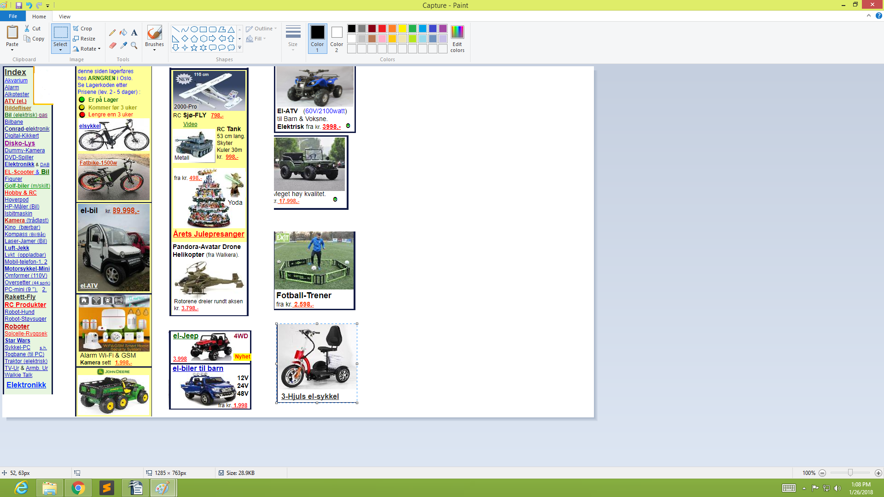

The original website was so compress then if you click one of the categories it is combination of other item. Then the improvement of the edited design is goo because the user can easily open it and easily to detect what item that a user needed.Then it has a passive and active white space that can call the attention of the user that it is easy to use just like the original one it has no passive and active white space that's how a user cannot easily to locate an item that a user needed.

6.Test cross-browser compatibility.
  - Make sure you have recent versions of at least two current browsers installed on your computer.
  - Browse a variety of Web sites. Make sure to view various pages of the sites in the diï¬€ erent browsers.
  - Write a detailed description of how the various sites appear in the browsers you have chosen. Look for text, layout, and graphic inconsistencies

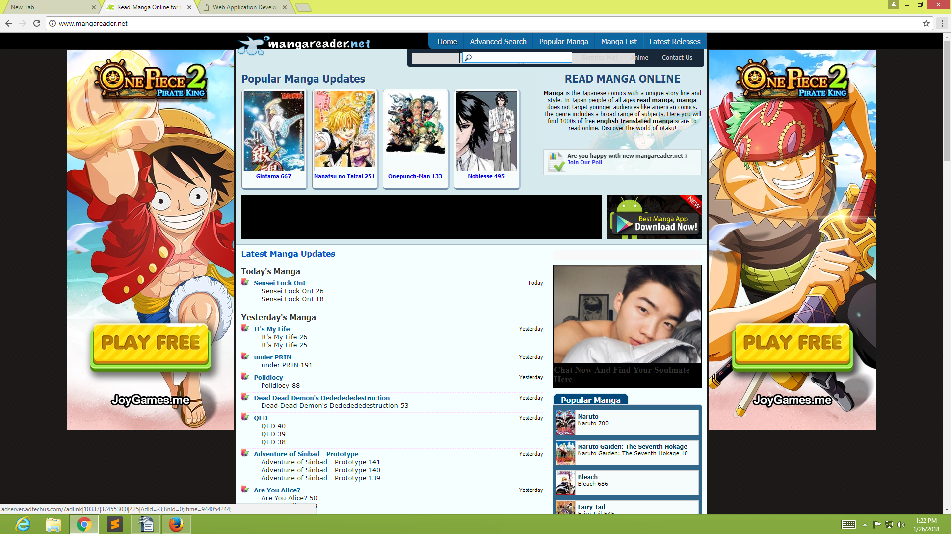
Google Chrome

Mozilla Firefox
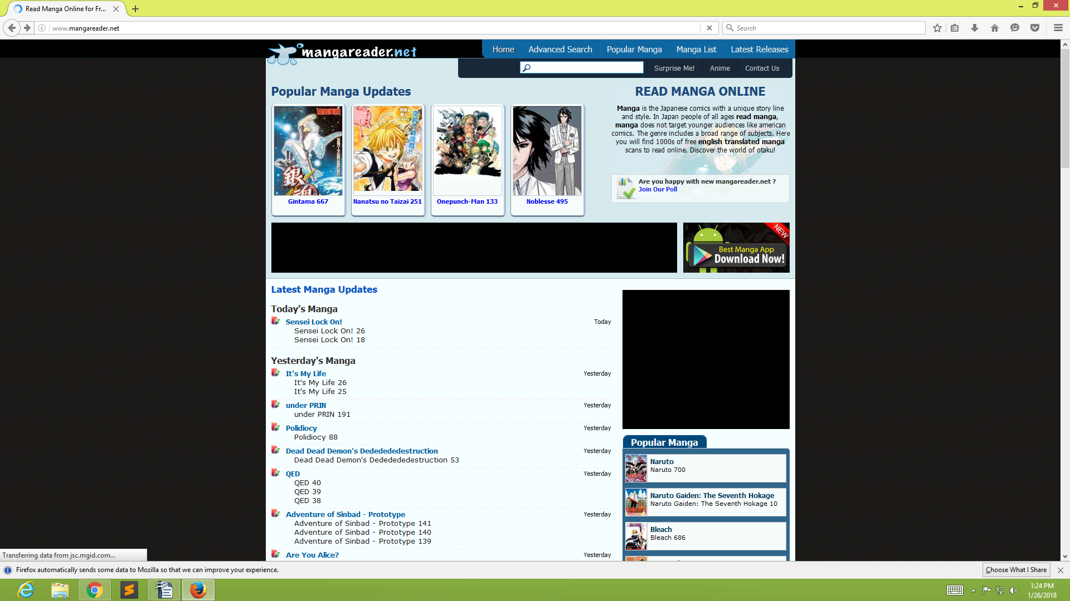
  - Write a detailed description of how the various sites appear in the browsers you have chosen. Look for text, layout, and graphic inconsistencies

-This two website have the same text to use but the inconsistencies of this two in their layout and graphic is that if you look at the layout of mozilla firefox it has two search menu but if you look google chrome it has only one search menu. Then for example if you open one particular site that you want in google chrome then you click the menu the site that you open will remain in the home page but in mozilla firefox it now show at all. In mozilla firefox the tool bar was directly open even if you open it in the home page but in google chrome it doesn't show.

